CURRICULAM VITAE

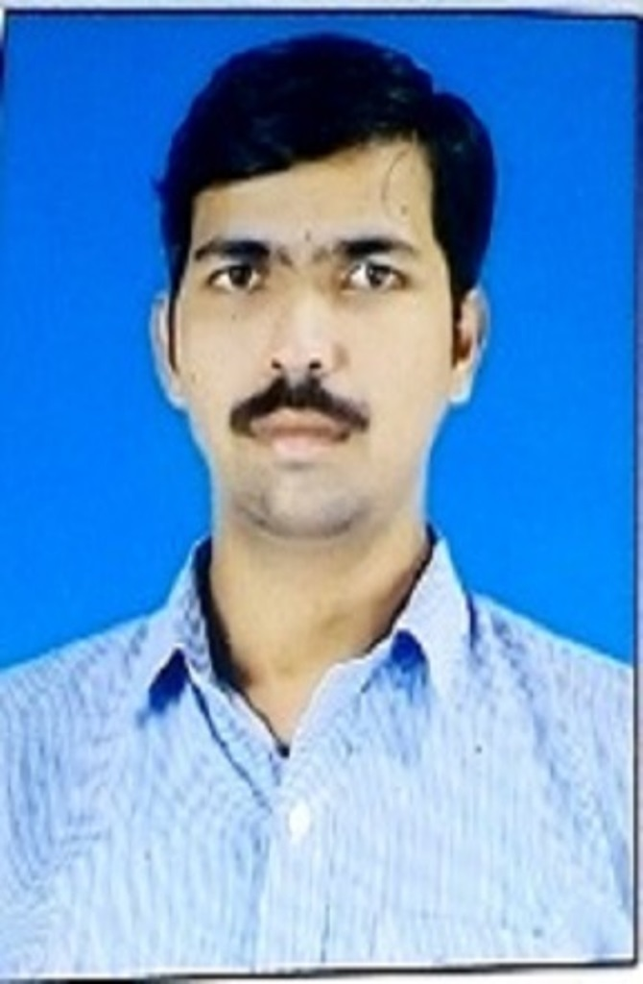
RAKESH KUMAR DAYARAM VISHWAKARMA
Room no. 5 Swapnapurti colony, MG rd.,
Opp. Kaka Dhaba, Nandiwali,
Kalyan(E) 421306
Mob- 7506639204
Email- r.vishwakarma28@gmail.com

CAREER OBJECTIVE:

- To acquired a position in an organization which is more suited to my knowledge.

EDUCATIONAL QUALIFICATIONS:

 | SCHOOL/COLLEGE | BOARD | YEAR | PERCENTAGE
S.S.C. | Lal bahadur shastri high school Varanasi | Uttar Pradesh board | March 2004 | 69.83%
H.S.C. | Sardar Patel Inter College Varanasi | Uttar Pradesh board | March 2006 | 63%
MS-CIT | Maharashtra State Board Technical Education | Maharashtra | July 2008 | 74%
B.C.A. | Yashwantrao Chavan Maharashtra Open University, Nashik | Maharashtra | June 2016 | --

TECHNICAL SKILLS:

Knowledge of ASP.Net, JAVA, AutoCAD, Photoshop, DBMS.

EXTRA CURRICULAR ACTIVITIES:

Team Leader of our B.C.A. Project

PERSONAL DETAILS
Father’s Name : Dayaram vishwakarma
Date of Birth : 20th September 1989
Gender : Male
Nationality : Indian
Languages Known : Hindi, English & Marathi
Religion : Hindu
First Language : Hindi
Hobbies : Playing Chess, Watching Movies.

DECLARATION:

I hereby declare that the information furnished above is true to the best of my knowledge and subject to verification.

Reference's Name :
Company Name :
Address :
Contact No. :
E-mail ID :

Date :
Place : signature

